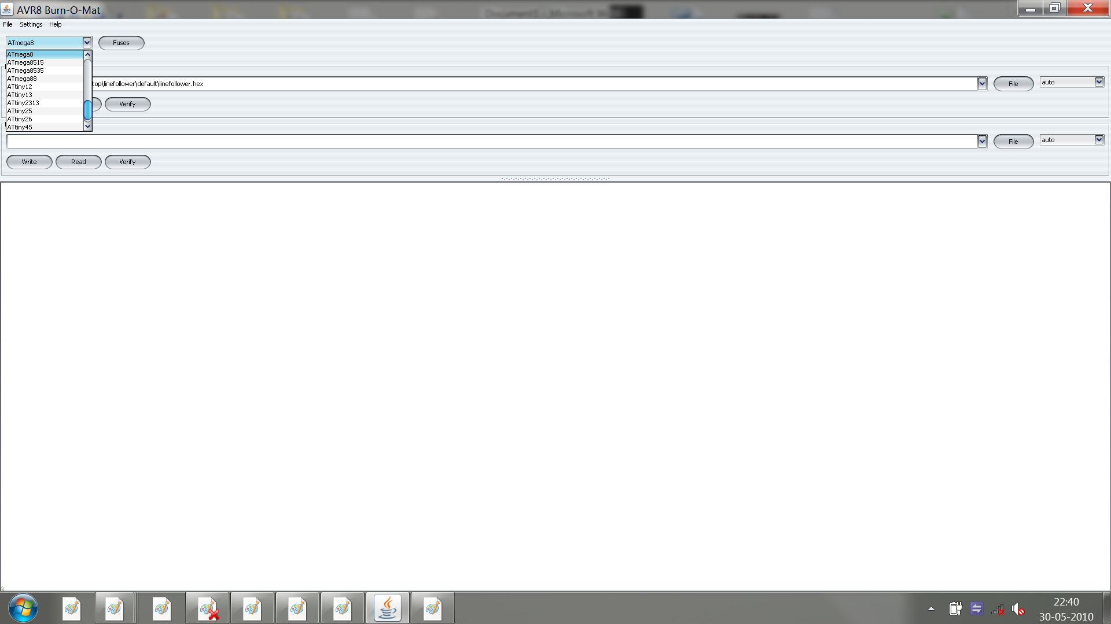
Step 1 : Open Burn O MAT, Select Atmega 8
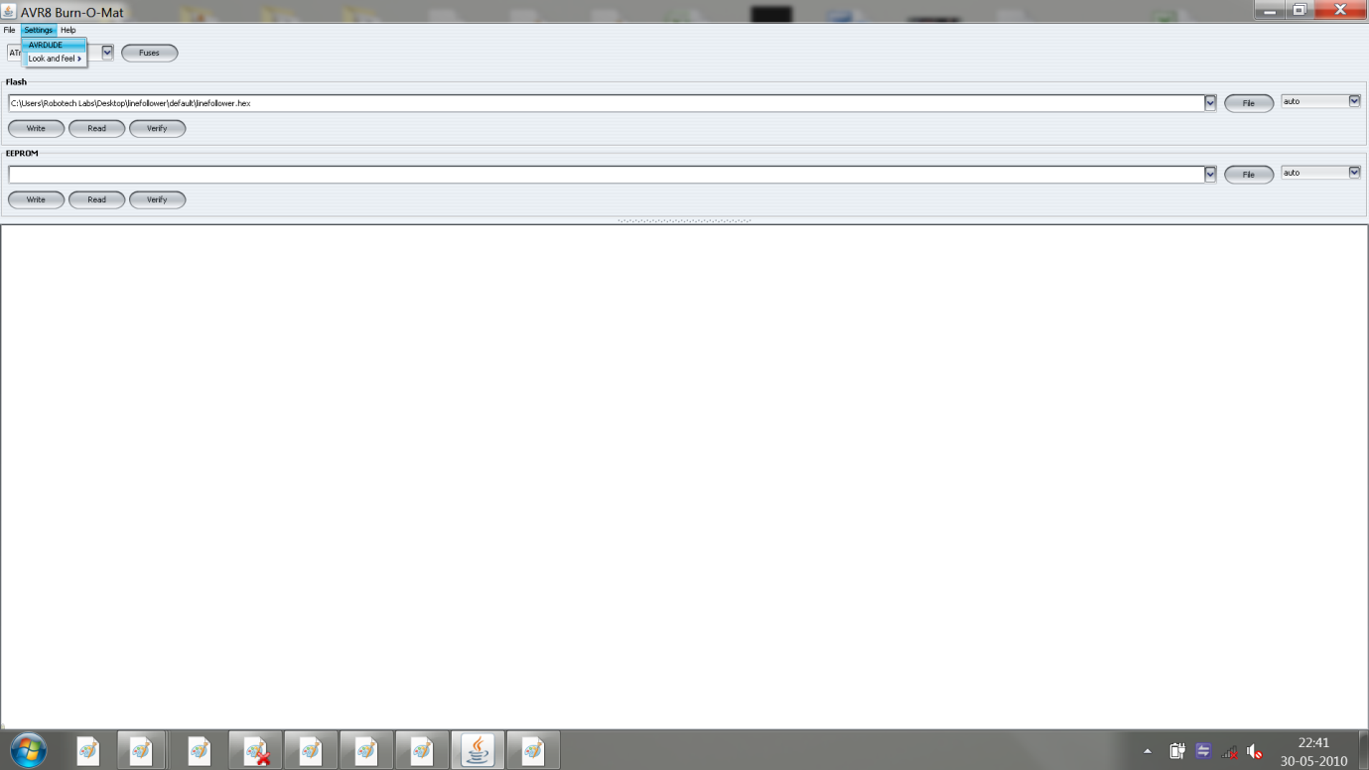
Step 2 :Go to Settings , then AVRDUDE
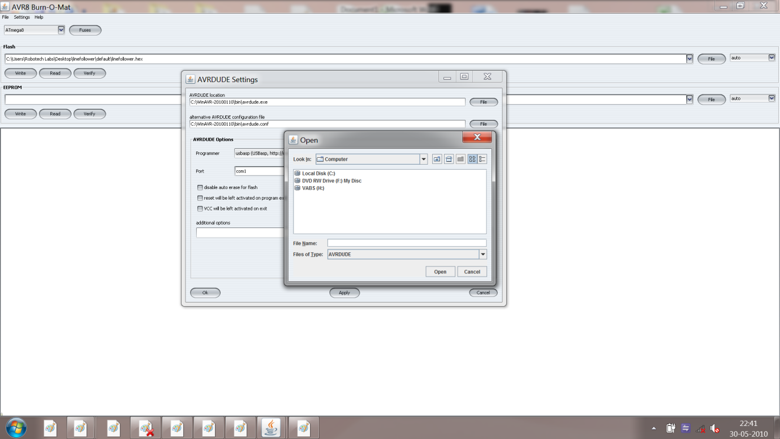

Step 3 : Change the location of path of both the files i.e .exe and .conf for WINAVR
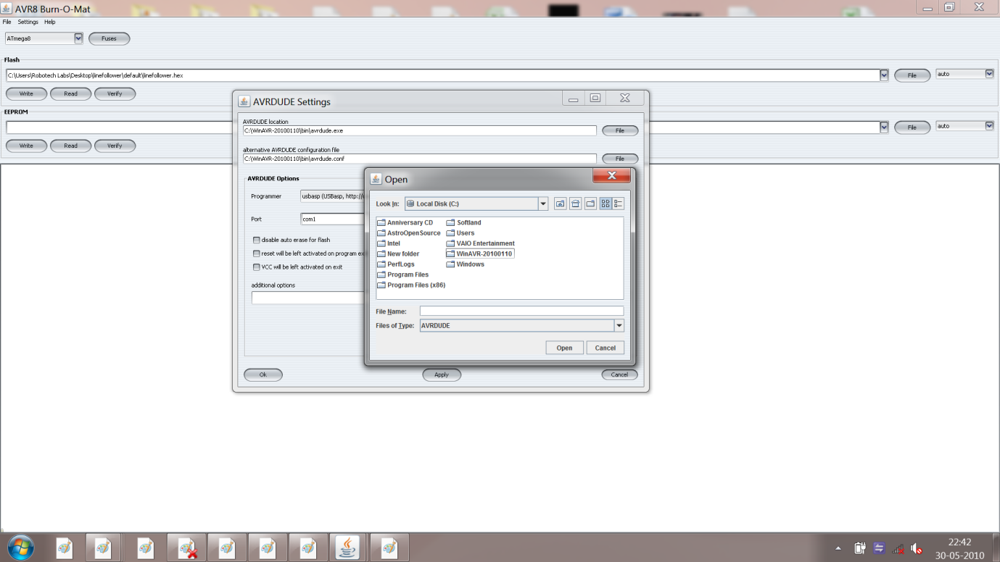
Step 4 :Go to the main C Folder , where you installed WINAVR
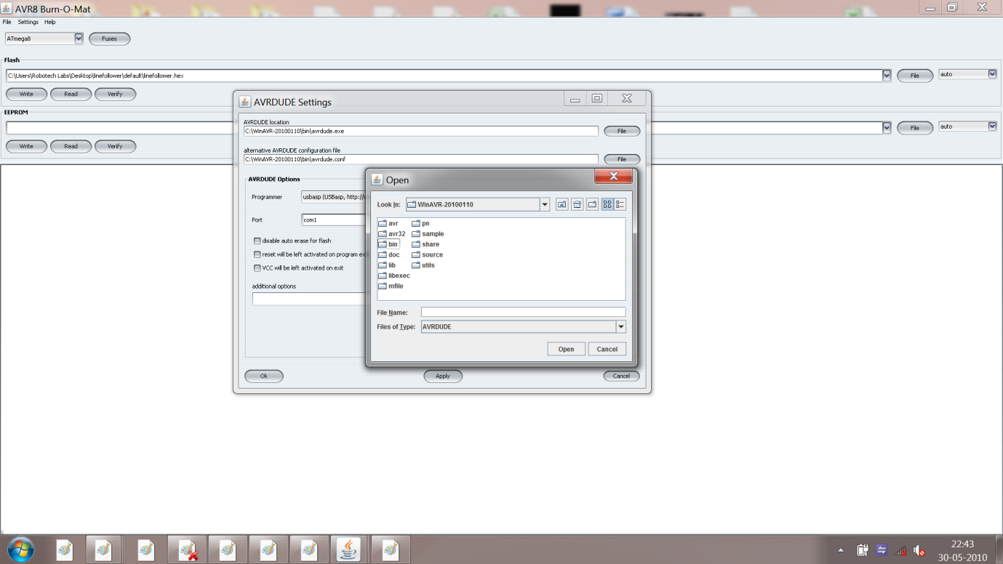
Step 5: Go to bin
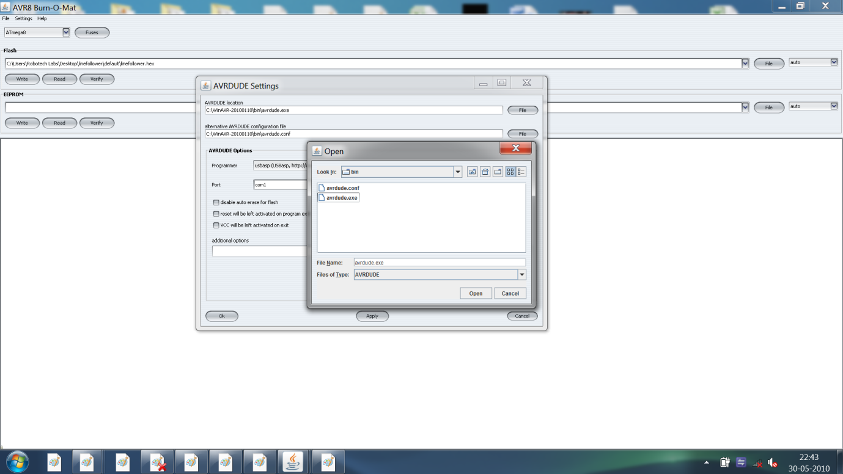
Step6 : Select the files , click ok.
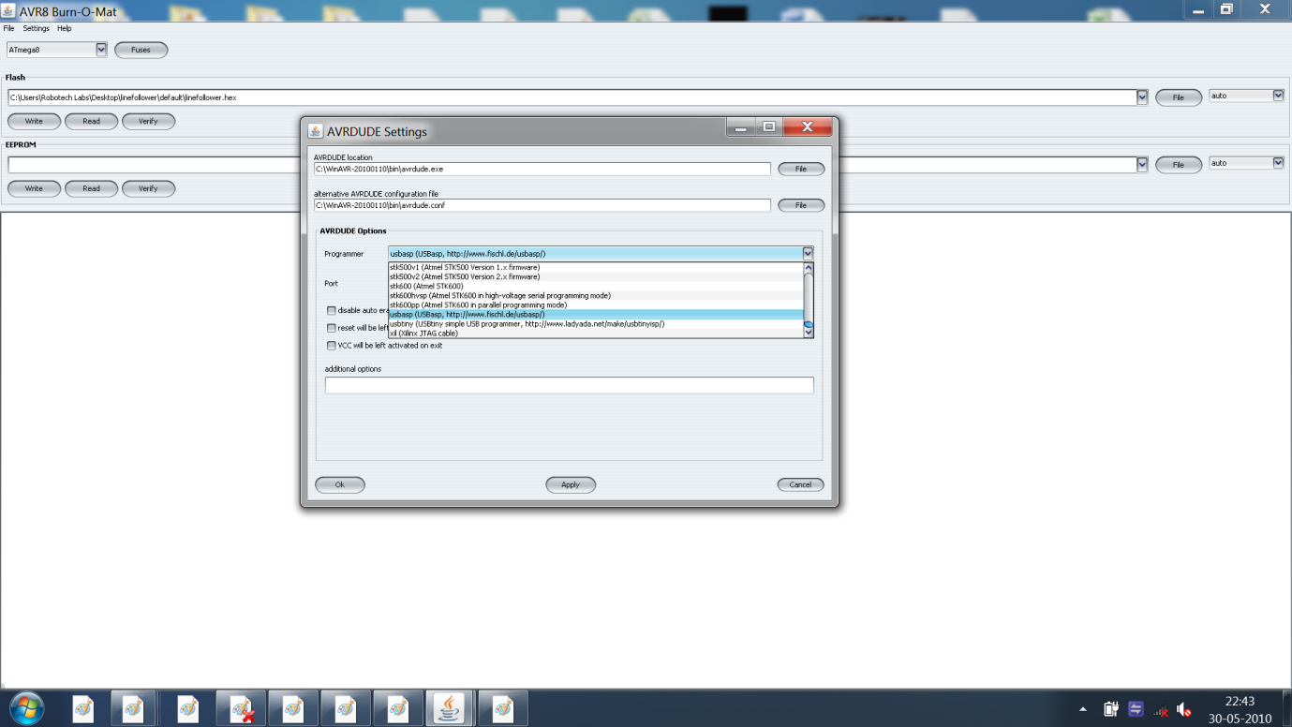
Step 7 :Select the programmer as USBASP
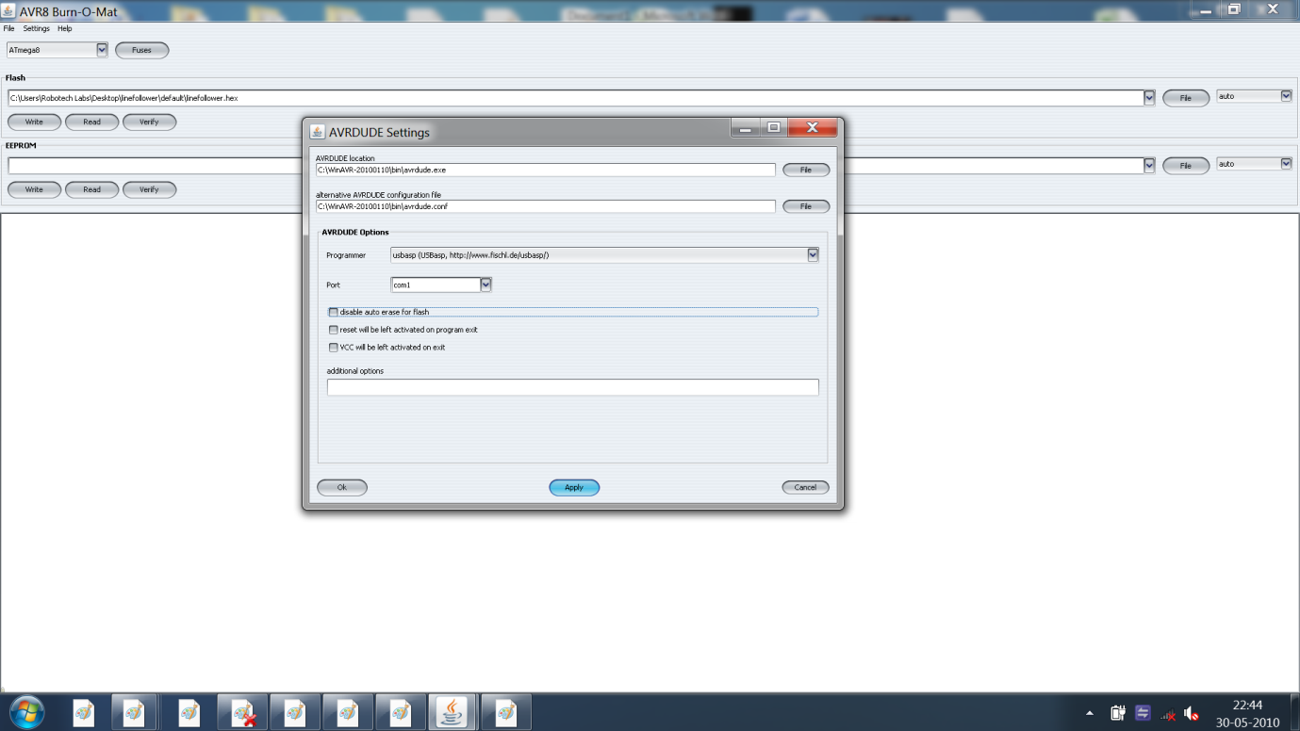
Step 8 :Select the Com port 1
Step 9:Apply the settings.
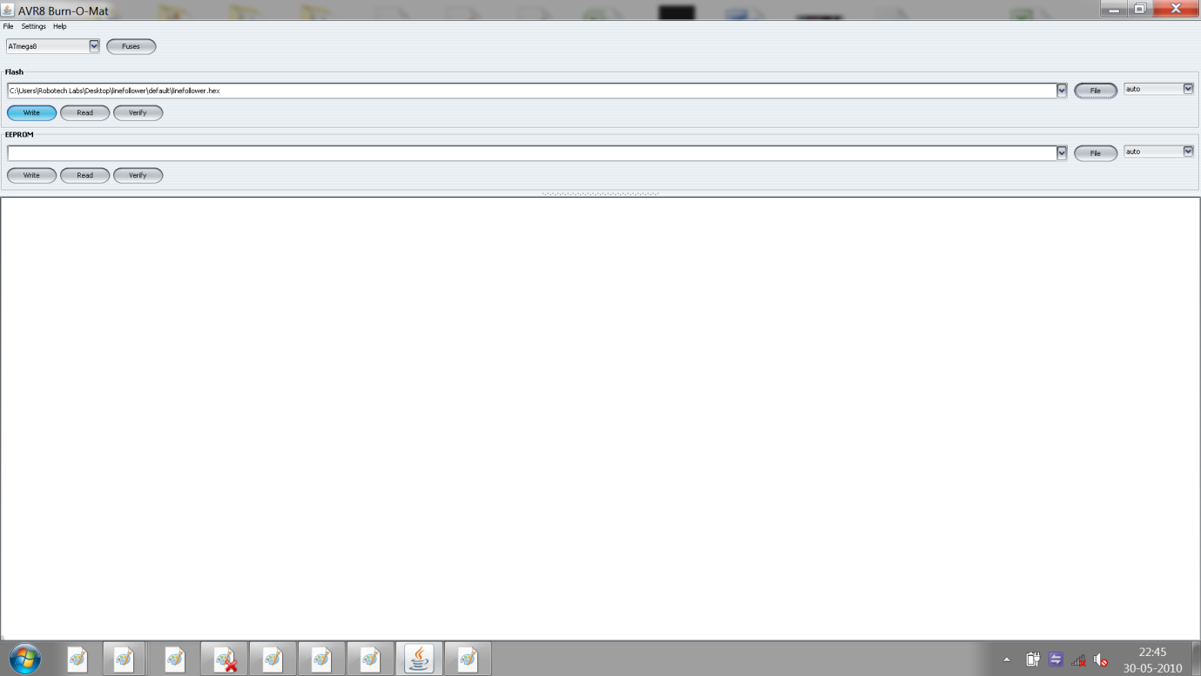
Come to the main window , write the program

